ATHENS EPIDAURUS FESTIVAL 2021 – VISUAL ARTS

Tassos Vrettos
The Feel. Backstage
Peiraios 260 – Hall Α
June 16 – July 31
Visiting hours: 19:00-24:00
Free admission with complimentary tickets

The adults-only, multimedia installation The Feel. Backstage carries us to the largely unseen part of the lives of Greek and international performers of the clubbing, BDSM and drag scene in Athens, captured by well-known Greek photographer Tassos Vrettos.

One of the artist’s most original works, it began through a chance meeting between Vrettos and the American drag queen Nickie Nicole at an Athens club back in 2005. The project evolved beyond strict ‘research’ protocols, on the basis of Vrettos’s personal relationships with the people inhabiting these spaces (producers, musicians, performers, gender activists) and his response to the events and festivals occasionally held at alternative spaces and venues in Athens.

Tassos Vrettos gradually assembled a photographic body of an idiosyncratic performative character and multiple anthropological and sociological signifiers. The material intersects with the history of LGBTQI+ and gender activism, social claims for sexual liberation, the right to pleasure and self-determination in the context of clubbing commons and sex festivals, the rituals of desire and precarious living; features which take centre stage in the public sphere from the era of extroverted, affluent post-Olympic Athens (2005) onwards. Following the advent of the crisis, differentiations of these features reach us today, enhanced through the complexity of queer culture and the dynamics of trans visibility.

The exhibition constitutes the starting point of a broader presentation of Tassos Vrettos’s 40-year work, to be realized across different spaces and times in 2021 and 2022, with the support of the NEON Organization for Culture and Development and the
collaboration of Onassis Foundation for the exclusive sponsorship of an extensive bilingual book on Tassos Vrettos’s oeuvre.

Tassos Vrettos
Athens-based Greek photographer Tassos Vrettos has been active in photography since 1979, both through solo artistic projects and as head of the photographic department of the Grammi publishing company and subsequently Lampraki Press Group, and currently as founder of studio vrettos.
http://www.studiovrettos.gr
Vrettos has collaborated with Manos Hadjidakis in the Tetarto magazine and has also worked with almost all Greek fashion magazines, several recording companies, and for great advertising campaigns in Greece and abroad. His photos have been published in international and Greek magazines and several books. He has also participated in numerous exhibitions, encompassing a long list of presentations and collaborations.
His most recent solo exhibition included the photographic portfolio “Wor(th)ship”, presented at the Benaki Museum in Athens (2015), the Thessaloniki Museum of Photography and the Macedonian Museum of Modern Art in Thessaloniki (2017), and the Les Recontres d’ Arles photography festival in France (2016).

Curated by Nadja Argyropoulou, Yorgos Tzirtzilakis
Production & Space design assistant Sofia Tektonidou
Design & Application of audiovisuals Makis Faros, Antonis Gatzougiannis, Michalis Antonopoulos
Lighting design Nikos Vlasopoulos
Soundscape Dimitris Kalamaras

The exhibition contains sensitive content and is suitable for audiences over the age of 18.
Free admission with complimentary tickets.
The Athens Epidaurus Festival adheres to all necessary public health protocols for the safety of the exhibition’s visitors.

With the support of ΝΕΟΝ Organization for Culture and Development

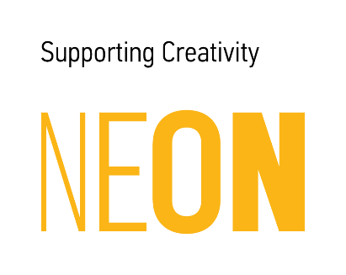

The design, production, and release of an extensive bilingual book on Tassos Vrettos’s oeuvre is exclusively sponsored by the Onassis Foundation

